Problem Description

Consider a matrix A of size $R^{nd x nd}$, where each non-overlapping d×d block of the matrix, $D_{ij}$, is a diagonal matrix. So, the matrix consists of $n^{2}$ such blocks. An example of such a matrix is shown below:

$$\left[\begin{matrix}D_{11} & D_{12} & D_{13} & … & D_{1n} \\ D_{21} & D_{22} & D_{23} & … & D_{2n} \\ … & … & … & … & … \\ D_{n1} & D_{n2} & D_{n3} & … & D_{nn}\end{matrix}\right]$$

Construct an efficient data structure to represent such matrices and devise algorithms to perform matrix operations, such as matrix multiplications and matrix inverse, on the data structure you designed. Provide a technical write-up of your solution along with associated code implementing your solution.

Solution

I. Matrix Multiplication

A= $\left[\begin{matrix}D1 & D2 \\ D3 & D4\end{matrix}\right]$ , B= $\left[\begin{matrix}D5 & D6 \\ D7 & D8\end{matrix}\right]$ A * B = $\left[\begin{matrix}\left(D1*D5\right)+(D2*D7) & \left(D1*D6\right)+(D2*D8) \\ \left(D3*D5\right)+(D4*D7) & \left(D3*D6\right)+(D4*D8)\end{matrix}\right]$
D1 = $\left[\begin{matrix}1 & 0 \\ 0 & 2\end{matrix}\right]$, D2 = $\left[\begin{matrix}3 & 0 \\ 0 & 4\end{matrix}\right]$, D3 = $\left[\begin{matrix}5 & 0 \\ 0 & 6\end{matrix}\right]$, D4 = $\left[\begin{matrix}7 & 0 \\ 0 & 8\end{matrix}\right]$, D5 = $\left[\begin{matrix}9 & 0 \\ 0 & 10\end{matrix}\right]$, D6 = $\left[\begin{matrix}11 & 0 \\ 0 & 12\end{matrix}\right]$, D7 = $\left[\begin{matrix}13 & 0 \\ 0 & 14\end{matrix}\right]$,
D8 = $\left[\begin{matrix}15 & 0 \\ 0 & 16\end{matrix}\right]$
A = $\left[\begin{matrix}\begin{matrix}1 & 0 \\ 0 & 2\end{matrix} & \begin{matrix}3 & 0 \\ 0 & 4\end{matrix} \\ \begin{matrix}5 & 0 \\ 0 & 6\end{matrix} & \begin{matrix}7 & 0 \\ 0 & 8\end{matrix}\end{matrix}\right]$ B = $\left[\begin{matrix}\begin{matrix}9 & 0 \\ 0 & 10\end{matrix} & \begin{matrix}11 & 0 \\ 0 & 12\end{matrix} \\ \begin{matrix}13 & 0 \\ 0 & 14\end{matrix} & \begin{matrix}15 & 0 \\ 0 & 16\end{matrix}\end{matrix}\right]$ A*B = $\left[\begin{matrix}\begin{matrix}48 & 0 \\ 0 & 76\end{matrix} & \begin{matrix}56 & 0 \\ 0 & 88\end{matrix} \\ \begin{matrix}123 & 0 \\ 0 & 182\end{matrix} & \begin{matrix}145 & 0 \\ 0 & 212\end{matrix}\end{matrix}\right]$
Since only the main diagonal in the matrices D1, D2,….., D8 have values and the resulting matrix (A*B) also have values only in the main diagonal.
For example, (D1 * D5) + (D2 * D7) = $\left[\begin{matrix}48 & 0 \\ 0 & 76\end{matrix}\right]$
It would be efficient to perform matrix multiplication only on the diagonal values and we don’t have to store the value zero for each matrix separately.

Suggested Method:
A = $\left[\begin{matrix}A11 & A12 & A13 & A14 \\ A21 & A22 & A23 & A24\end{matrix}\right]$ ① B = $\left[\begin{matrix}B11 & B12 & B13 & B14 \\ B21 & B22 & B23 & B24\end{matrix}\right]$ ②
A*B = $\left[\begin{matrix}\begin{matrix}A11*B11 & A12*B12 \\ A11*B13 & A12*B14\end{matrix} & \begin{matrix}A13*B21 & A14*B22 \\ A13*B23 & A14*B24\end{matrix} \\ \begin{matrix}A21*B11 & A22*B12 \\ A21*B13 & A22*B14\end{matrix} & \begin{matrix}A23*B21 & A24*B22 \\ A23*B23 & A24*B24\end{matrix}\end{matrix}\right]$ ③
- $\left[\begin{matrix}\begin{matrix}\begin{matrix}\left(A11*B11\right)+(A13*B21) & \left(A12*B12\right)+(A14*B22) \\ \left(A11*B13\right)+(A13*B23) & (A12*B14)+(A14*B24)\end{matrix} & \\ \begin{matrix}\left(A21*B11\right)+(A23*B21) & \left(A22*B12\right)+(A24*B22) \\ \left(A21*B13\right)+(A23*B23) & \left(A22*B14\right)+(A24*B24)\end{matrix} & \end{matrix}\end{matrix}\right]$ ④

A = $\left[\begin{matrix}1 & 2 & 3 & 4 \\ 5 & 6 & 7 & 8\end{matrix}\right]$ B = $\left[\begin{matrix}9 & 10 & 11 & 12 \\ 13 & 14 & 15 & 16\end{matrix}\right]$
A*B => $\left[\begin{matrix}\begin{matrix}\left(1* 9\right) & (2*10) \\ (1*11) & (2*12)\end{matrix} & \begin{matrix}(3*13) & (4*14) \\ (3*15) & (4*16)\end{matrix} \\ \begin{matrix}(5* 9) & (6*10) \\ (5*11) & (6*12)\end{matrix} & \begin{matrix}(7*13) & (8*14) \\ (7*15) & (8*16)\end{matrix}\end{matrix}\right]$ => $\left[\begin{matrix}9 & 20 & 39 & 56 \\ 11 & 24 & 45 & 64 \\ 45 & 60 & 91 & 112 \\ 55 & 72 & 105 & 128\end{matrix}\right]$
=> $\left[\begin{matrix}9+39 & 20+56 \\ 11+45 & 24+64 \\ 45+91 & 60+112 \\ 55+105 & 72+128\end{matrix}\right]$ => $\left[\begin{matrix}48 & 76 \\ 56 & 88 \\ 136 & 172 \\ 160 & 200\end{matrix}\right]$

Algorithm

- Setting up the matrices

dmatrixA [50][50]; // Matrix A
dmatrixB [50][50]; //Matrix B
dmatrixM [50][50]; // Matrix that holds the multiplied values
dmatrixF [50][50] = {0}; // Matrix that holds the final values

settingUpDMatrix (num, n, d) // Function to set the values for matrix A and B
{
//Setting up Matrix A

if(num==1) // If the num value is 1, matrix A is assigned values

for (i = 1 to n) // There are n rows for matrix A
for (j =1 to n*d) // There are n*d columns for matrix A
dmatrixA[i][j] = rand()%20 + 5 // Random values are stored in the A Matrix ①
end for
end for

for (i = 1 to n)
for (int j=1 to n*d)
print dmatrixA[i][j] // Printing the A Matrix
end for
end for

end if

//Setting up Matrix B
else

for (i=1 to n) // There are n rows for matrix B
for (j =1 to n*d) // There are n*d columns for matrix B
dmatrixB[i][j] = rand()%10 + 7 // Random values are stored in the B Matrix ②
end for
end for

for (i = 1 to n)
for (j=1 to n*d)
print dmatrixB[i][j] // Printing the B Matrix
end for
end for

end else

- Matrix Multiplication

void matrixMultiplication(n, d) // Function accepts n and d as arguments
{
arow=1, brow=1, bcol=1, start=1
/* arow – Holds the row value of matrix A
brow – Holds the row value of matrix B
bcol – Holds the column value of matrix B
start - Holds the column value of matrix B and helps in traversing the matrix*/

for (i=1 to n*n) // There are n*n rows for Matrix M
for(j=1 to n*d) // There are n*d columns for Matrix M
dmatrixM[i][j]=dmatrixA[arow][j] * dmatrixB[brow][bcol] //Setting up the matrix M ③

if(bcol%d ==0 and j==n*d)
if(bcol==n*d)
bcol=1;
start=1;
end if
else
start=start+d;
end else
break
end if

if(j%d==0)
brow=brow+1
end if

if(bcol%d==0)
bcol=start
end if
else
increment bcol by 1
end else

end for

brow=1

if(bcol!=1)
bcol=start
end if

if(i%n==0)
increment arow by 1 // Increments arow by 1 every nth time
end if
end for

for(i=1 to n*n)
for(j=1 to d)
for(k=j to n*d)
if(k<=n*d)
dmatrixF[i][j]=dmatrixF[i][j]+dmatrixM[i][k] // Setting up the final matrix F ④
end if
else
break
end else
k=k+d // k value helps in fixing on the column
end for
end for
end for
}
N | D | Number of elements in each Matrix A and B | No of rows in each Matrix A and B | No of columns in each matrix A and B
2 | 2 | 8 | 2 | 4
2 | 3 | 12 | 2 | 6
2 | 4 | 16 | 2 | 8
3 | 2 | 18 | 3 | 6
3 | 3 | 27 | 3 | 9
3 | 4 | 36 | 3 | 12

- Printing the matrices
void printmatrixM(n, d) // Function accepts n and d as arguments
{
for(i=1 to n*n)
for(j=1 to n*d)
print dmatrixM[i][j] // Printing the multiplied values ③
end for
end for
}

void printmatrixF(n, d) //Function accepts n and d as arguments
{
for(i=1 to n*n) // The final matrix contains n*n rows
for(j=1 to d) // The final matrix contains d columns
print dmatrixF[i][j] //Printing the final matrix F ④
end for
end for
}

Code File:

Output:
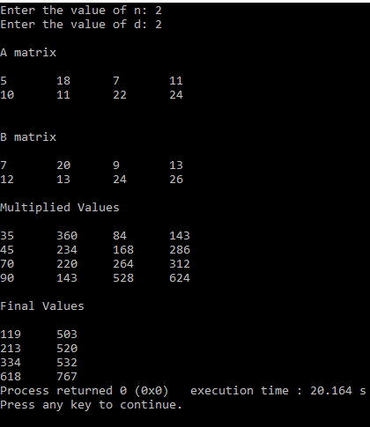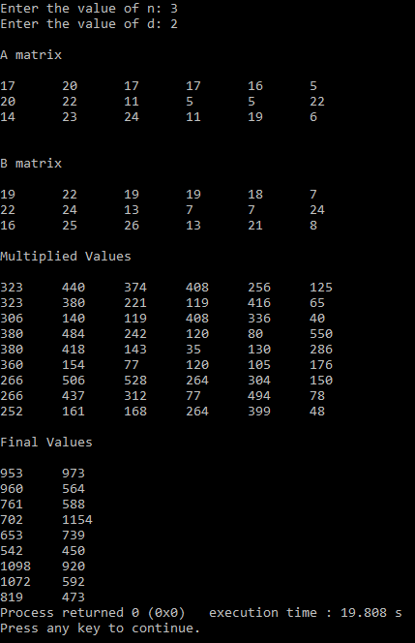

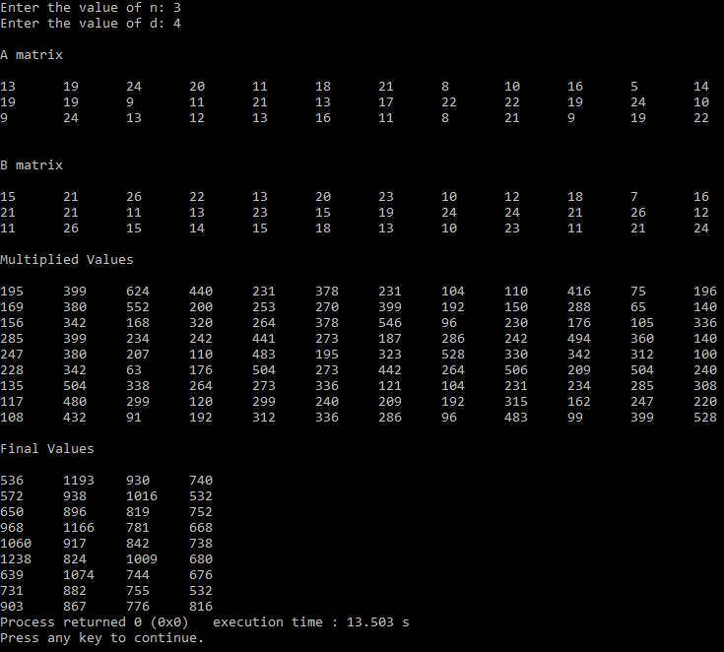

II. Matrix Inverse

To calculate matrix inverse, the matrix must be square.
Based on the values of n and d, below are some of the square matrices possible.
N | D | Number of Elements (Including Zeros) (N*N) * (D*D) | Perfect Square (N*D)
2 | 2 | 16 | 4
2 | 3 | 36 | 6
2 | 4 | 64 | 8
3 | 2 | 36 | 6
3 | 3 | 81 | 9
3 | 4 | 144 | 12

Suggested Method:
Since matrix inverse can be calculated only if the matrix is a square matrix, it is necessary to calculate it along with the zeros. We can treat the matrix as a single matrix that is made up of several diagonal matrices.

A= $\left[\begin{matrix}D1 & D2 \\ D3 & D4\end{matrix}\right]$ , D1 = $\left[\begin{matrix}1 & 0 \\ 0 & 2\end{matrix}\right]$, D2 = $\left[\begin{matrix}3 & 0 \\ 0 & 4\end{matrix}\right]$, D3 = $\left[\begin{matrix}5 & 0 \\ 0 & 6\end{matrix}\right]$, D4 = $\left[\begin{matrix}7 & 0 \\ 0 & 8\end{matrix}\right]$
A = $\left[\begin{matrix}\begin{matrix}1 & 0 \\ 0 & 2\end{matrix} & \begin{matrix}3 & 0 \\ 0 & 4\end{matrix} \\ \begin{matrix}5 & 0 \\ 0 & 6\end{matrix} & \begin{matrix}7 & 0 \\ 0 & 8\end{matrix}\end{matrix}\right]$ ①

In this method, we append the A matrix with the identity matrix of the same dimension to it.
A = $\left[\begin{matrix}\begin{matrix}1 & 0 \\ 0 & 2\end{matrix} & \begin{matrix}3 & 0 & 1 & 0 & 0 & 0 \\ 0 & 4 & 0 & 1 & 0 & 0\end{matrix} \\ \begin{matrix}5 & 0 \\ 0 & 6\end{matrix} & \begin{matrix}7 & 0 & 0 & 0 & 1 & 0 \\ 0 & 8 & 0 & 0 & 0 & 1\end{matrix}\end{matrix}\right]$ ②
We then reduce the left matrix to row echelon form using elementary row operations for the whole matrix (including the right one).
A = $\left[\begin{matrix}\begin{matrix}1 & 0 \\ 0 & 1\end{matrix} & \begin{matrix}0 & 0 & -0.875 & 0 & 0.375 & 0 \\ 0 & 0 & 0 & -1 & 0 & 0.5\end{matrix} \\ \begin{matrix}0 & 0 \\ 0 & 0\end{matrix} & \begin{matrix}1 & 0 & 0.625 & 0 & -0.125 & 0 \\ 0 & 1 & 0 & 0.75 & 0 & -0.25\end{matrix}\end{matrix}\right]$ ③
We get the inverse calculated to the right.

Algorithm

- Setting up the matrix

n, d, pos=1 //Global variables
dmatrixA[50][50]={0} // The matrix A is of float type since it should hold the decimal values

void settingUpDMatrix(n, d)
{
cnt=1 // cnt variable keeps track of the column value of matrix A

for(i=1 to n*d) // There are n*d rows in matrix A
cnt=i%d

if(cnt==0)
cnt=d
end if

for(j=1 to n*d) // There are n*d columns in matrix A
if(cnt==j)
dmatrixA[i][j]=rand()%20 + 1 // Random values are stored in the matrix A ①
end if
if(cnt+d==j)
dmatrixA[i][j]=rand()%20 + 1
cnt=cnt+d
end if
end for

end for

cnt=n*d

for(i=1 to n*d)
increment cnt by 1
dmatrixA[i][cnt]=1 // Appending the Identity matrix of the same dimension ②
end for

for(i=1 to n*d)
for(j=1 to 2*n*d)
print dmatrixA[i][j] // Printing matrix A along with the appended Identity matrix
end for
end for

}

- Matrix Inverse

divideRow(row, val) //This function divides a row. The variable val should be of float type.
{
for(j=1 to 2*n*d)
if(val!=0) // To make sure we don’t divide by zero
dmatrixA[row][j]=dmatrixA[row][j]/val
end if
end for
}

subRow(row, j, val) // This function subtracts a row from another row starting from the same column
{
for(j to 2*n*d)
dmatrixA[row][j]=dmatrixA[row][j] - (val*dmatrixA[pos][j])
end for
}

diagonalOne(i) // This function is used make the diagonal values as 1 on the left side
{
val
if(dmatrixA[i][i]!=1)
val=dmatrixA[i][i]
divideRow(i,val)
end if
}

matrixInverse()
{
val // val holds a single value of matrix A at a time

for(j=1 to n*d)
diagonalOne(j)

for(i=1 to n*d) // We are traversing it column wise. To make all the column entries zero except those in the diagonal intersections like 11,22,33 etc.
if(i!=j and dmatrixA[i][j]!=0)
val=dmatrixA[i][j]
subRow(i,j,val)
end if
end for
increment pos by 1 // This variable holds the row value
end for
}

- Printing the matrix

printMatrix()
{
for(i=1 to n*d)
for(j=1 to 2*n*d)
print dmatrixA[i][j] // Printing the matrix inverse ③
end for
end for
}

Code File:

Output:
